**File name : 1. spring-rest-handson**

**Hands on 1**

**Create a Spring Web Project using Maven**

**SpringLearnApplication.java**

package com.cognizant.spring_learn;

import org.slf4j.Logger;

import org.slf4j.LoggerFactory;

import org.springframework.boot.SpringApplication;

import org.springframework.boot.autoconfigure.SpringBootApplication;

*@SpringBootApplication*

public class SpringLearnApplication {

private static final Logger ***LOGGER*** = LoggerFactory.*getLogger*(SpringLearnApplication.class);

public static void main(String[] args) {

***LOGGER***.info("START");

SpringApplication.*run*(SpringLearnApplication.class, args);

***LOGGER***.info("END");

}

}

**Pom.xml**

<?xml version="1.0" encoding="UTF-8"?>

<project xmlns="http://maven.apache.org/POM/4.0.0" xmlns:xsi="http://www.w3.org/2001/XMLSchema-instance"

xsi:schemaLocation="http://maven.apache.org/POM/4.0.0 https://maven.apache.org/xsd/maven-4.0.0.xsd">

<modelVersion>4.0.0</modelVersion>

<parent>

<groupId>org.springframework.boot</groupId>

<artifactId>spring-boot-starter-parent</artifactId>

<version>3.5.3</version>

<relativePath/> <!-- lookup parent from repository -->

</parent>

<groupId>com.cognizant</groupId>

<artifactId>spring-learn</artifactId>

<version>0.0.1-SNAPSHOT</version>

<name>spring-learn</name>

<description>Demo project for Spring Boot</description>

<url/>

<licenses>

<license/>

</licenses>

<developers>

<developer/>

</developers>

<scm>

<connection/>

<developerConnection/>

<tag/>

<url/>

</scm>

<properties>

<java.version>17</java.version>

</properties>

<dependencies>

<dependency>

<groupId>org.springframework.boot</groupId>

<artifactId>spring-boot-starter-web</artifactId>

</dependency>

<dependency>

<groupId>org.springframework.boot</groupId>

<artifactId>spring-boot-devtools</artifactId>

<scope>runtime</scope>

<optional>true</optional>

</dependency>

<dependency>

<groupId>org.springframework.boot</groupId>

<artifactId>spring-boot-starter-test</artifactId>

<scope>test</scope>

</dependency>

</dependencies>

<build>

<plugins>

<plugin>

<groupId>org.springframework.boot</groupId>

<artifactId>spring-boot-maven-plugin</artifactId>

</plugin>

</plugins>

</build>

</project>

**OUTPUT:**

**Application:**

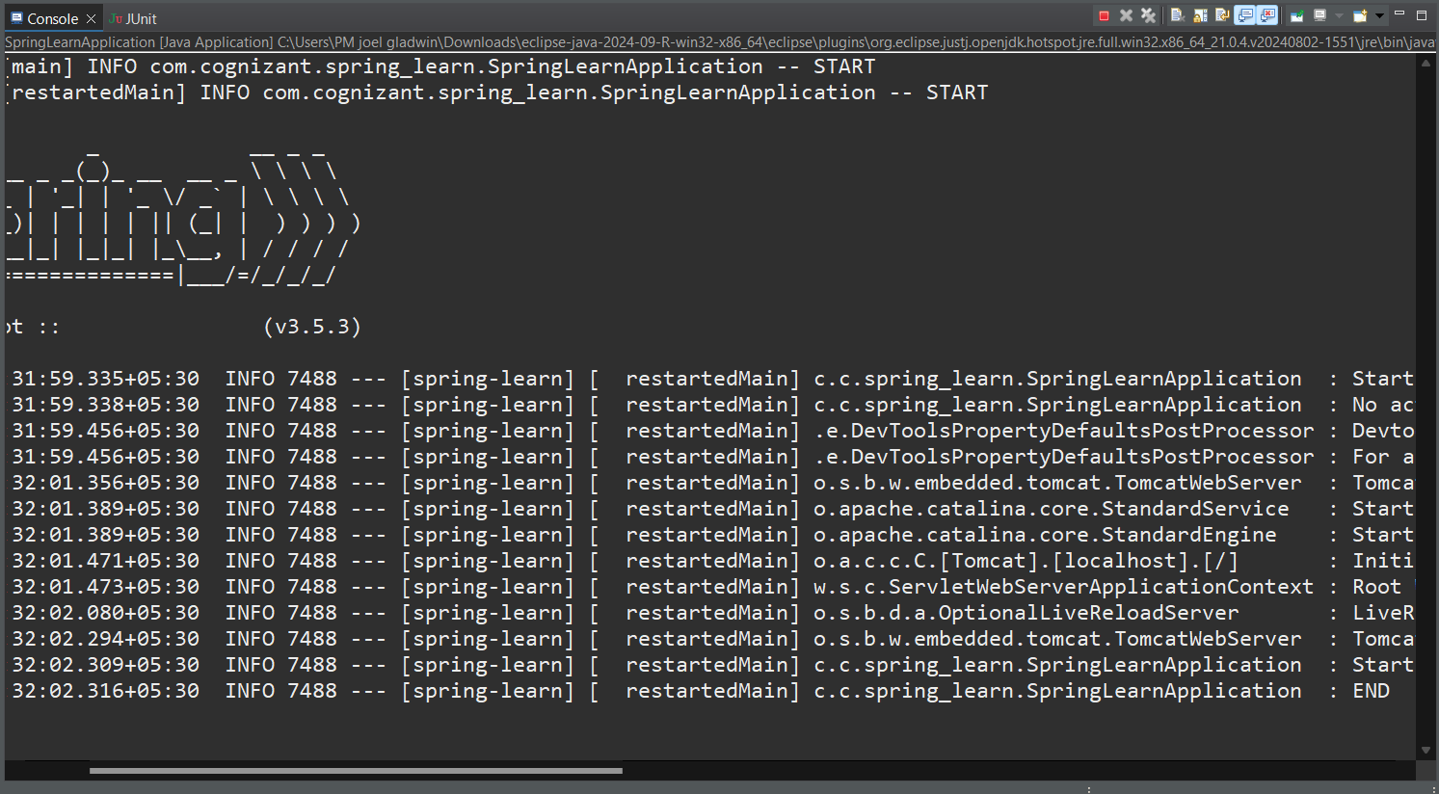

**Dependency Hierarchy:**

**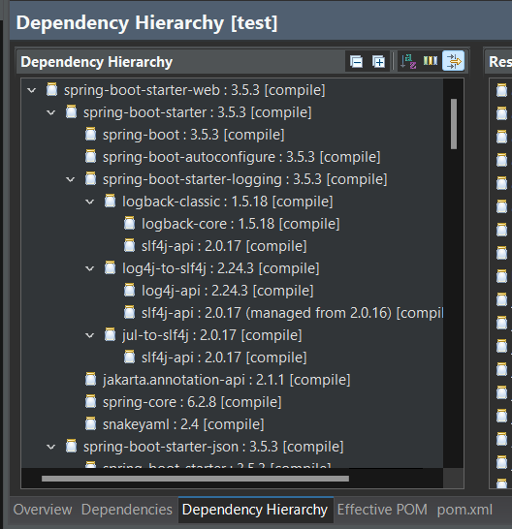  
  
  
  
Hands on 4**

**Spring Core – Load Country from Spring Configuration XML   
  
Country.java**

package com.cognizant.spring_learn;

import org.slf4j.Logger;

import org.slf4j.LoggerFactory;

public class Country {

private static final Logger ***LOGGER*** = LoggerFactory.*getLogger*(Country.class);

private String code;

private String name;

public Country() {

***LOGGER***.debug("Inside Country Constructor.");

}

public String getCode() {

***LOGGER***.debug("Inside getCode()");

return code;

}

public void setCode(String code) {

***LOGGER***.debug("Inside setCode()");

this.code = code;

}

public String getName() {

***LOGGER***.debug("Inside getName()");

return name;

}

public void setName(String name) {

***LOGGER***.debug("Inside setName()");

this.name = name;

}

*@Override*

public String toString() {

return "Country [code=" + code + ", name=" + name + "]";

}

}

**country.xml**

<?xml version="1.0" encoding="UTF-8"?>

<beans xmlns="http://www.springframework.org/schema/beans"

xmlns:xsi="http://www.w3.org/2001/XMLSchema-instance"

xsi:schemaLocation="

http://www.springframework.org/schema/beans

http://www.springframework.org/schema/beans/spring-beans.xsd">

<bean id="country" class="com.cognizant.spring_learn.Country">

<property name="code" value="IN"/>

<property name="name" value="India"/>

</bean>

</beans>

**SpringLearnApplication.java**

package com.cognizant.spring_learn;

import org.slf4j.Logger;

import org.slf4j.LoggerFactory;

import org.springframework.boot.SpringApplication;

import org.springframework.boot.autoconfigure.SpringBootApplication;

import org.springframework.context.ApplicationContext;

import org.springframework.context.support.ClassPathXmlApplicationContext;

*@SpringBootApplication*

public class SpringLearnApplication {

private static final Logger ***LOGGER*** = LoggerFactory.*getLogger*(SpringLearnApplication.class);

public static void main(String[] args) {

***LOGGER***.info("START");

SpringApplication.*run*(SpringLearnApplication.class, args);

*displayCountry*();

***LOGGER***.info("END");

}

public static void displayCountry() {

ApplicationContext context = new ClassPathXmlApplicationContext("country.xml");

Country country = (Country) context.getBean("country", Country.class);

***LOGGER***.debug("Country : {}", country.toString());

}

}

**OUTPUT:**

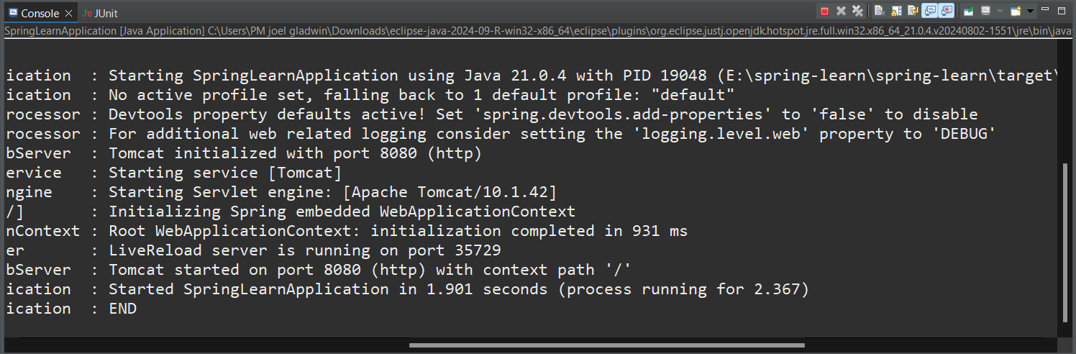

**File name : 2. spring-rest-handson**

**Hello World RESTful Web Service**

**HelloController.java**

package com.cognizant.spring_learn.controller;

import org.slf4j.Logger;

import org.slf4j.LoggerFactory;

import org.springframework.web.bind.annotation.GetMapping;

import org.springframework.web.bind.annotation.RestController;

*@RestController*

public class HelloController {

private static final Logger ***LOGGER*** = LoggerFactory.*getLogger*(HelloController.class);

*@GetMapping*("/hello")

public String sayHello() {

***LOGGER***.info("START - sayHello()");

String message = "<h1>Hello World!!</h1>";

***LOGGER***.info("END - sayHello()");

return message;

}

}

**application.properties**

spring.application.name=spring-learn

server.port=8083

logging.level.com.cognizant.spring_learn=DEBUG

**OUTPUT:**

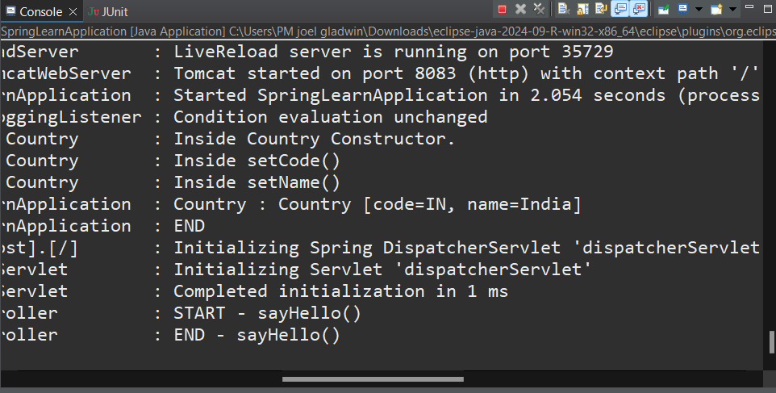

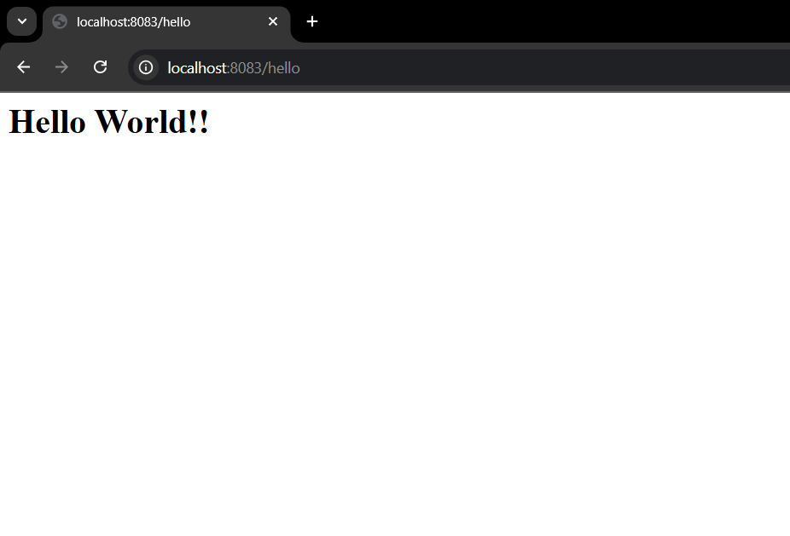

**REST - Country Web Service**

**CountryController.java**

package com.cognizant.spring_learn.controller;

import com.cognizant.spring_learn.Country;

import com.cognizant.spring_learn.service.CountryService;

import org.slf4j.Logger;

import org.slf4j.LoggerFactory;

import org.springframework.context.ApplicationContext;

import org.springframework.context.support.ClassPathXmlApplicationContext;

import org.springframework.web.bind.annotation.*;

*@RestController*

public class CountryController {

private static final Logger ***LOGGER*** = LoggerFactory.*getLogger*(CountryController.class);

private final CountryService countryService;

public CountryController(CountryService countryService) {

this.countryService = countryService;

}

*@RequestMapping*("/country")

public Country getCountryIndia() {

***LOGGER***.info("START - getCountryIndia()");

ApplicationContext context = new ClassPathXmlApplicationContext("country.xml");

Country country = context.getBean("country", Country.class);

***LOGGER***.info("END - getCountryIndia()");

return country;

}

}

**OUTPUT:**

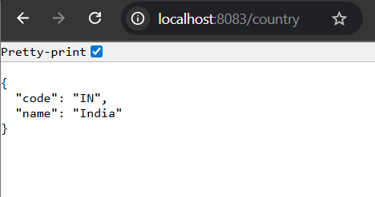

**REST - Get country based on country code**

**CountryController.java**

package com.cognizant.spring_learn.controller;

import com.cognizant.spring_learn.Country;

import com.cognizant.spring_learn.service.CountryService;

import org.slf4j.Logger;

import org.slf4j.LoggerFactory;

import org.springframework.web.bind.annotation.*;

@RestController

public class CountryController {

private static final Logger LOGGER = LoggerFactory.getLogger(CountryController.class);

private final CountryService countryService;

public CountryController(CountryService countryService) {

this.countryService = countryService;

}

@GetMapping("/countries/{code}")

public Country getCountry(@PathVariable String code) {

LOGGER.info("START - getCountry()");

Country country = countryService.getCountry(code);

LOGGER.info("END - getCountry()");

return country;

}

}

**CountryService.java**

package com.cognizant.spring_learn.service;

import com.cognizant.spring_learn.Country;

import org.slf4j.Logger;

import org.slf4j.LoggerFactory;

import org.springframework.stereotype.Service;

import org.springframework.context.ApplicationContext;

import org.springframework.context.support.ClassPathXmlApplicationContext;

import java.util.List;

*@Service*

public class CountryService {

private static final Logger ***LOGGER*** = LoggerFactory.*getLogger*(CountryService.class);

public Country getCountry(String code) {

***LOGGER***.info("START - getCountry()");

ApplicationContext context = new ClassPathXmlApplicationContext("country.xml");

List<Country> countries = context.getBean("countryList", List.class);

return countries.stream()

.filter(c -> c.getCode().equalsIgnoreCase(code))

.findFirst()

.orElse(null); // Optionally, you can throw an exception here

}

}

**SpringLearnApplication.java**

package com.cognizant.spring_learn;

import org.slf4j.Logger;

import org.slf4j.LoggerFactory;

import org.springframework.boot.SpringApplication;

import org.springframework.boot.autoconfigure.SpringBootApplication;

import org.springframework.context.ApplicationContext;

import org.springframework.context.support.ClassPathXmlApplicationContext;

*@SpringBootApplication*

public class SpringLearnApplication {

private static final Logger ***LOGGER*** = LoggerFactory.*getLogger*(SpringLearnApplication.class);

public static void main(String[] args) {

***LOGGER***.info("START");

SpringApplication.*run*(SpringLearnApplication.class, args);

*displayCountry*();

***LOGGER***.info("END");

}

public static void displayCountry() {

ApplicationContext context = new ClassPathXmlApplicationContext("country.xml");

Country country = (Country) context.getBean("country", Country.class);

***LOGGER***.debug("Country : {}", country.toString());

}

}

**OUTPUT:**

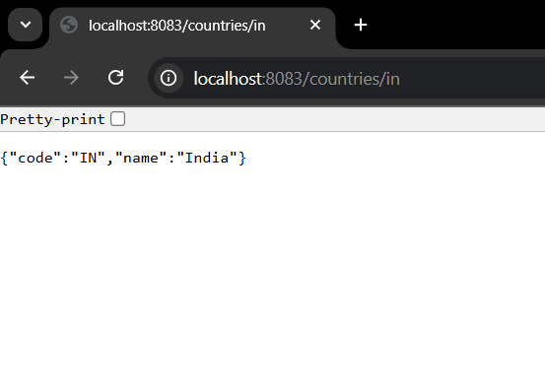

**File name: 5. JWT-handson**

**Create authentication service that returns JWT**

**JwtUtil.java**

package com.example.jwtauth.util;

import io.jsonwebtoken.Jwts;

import io.jsonwebtoken.SignatureAlgorithm;

import java.util.Date;

public class JwtUtil {

public static String generateToken(String username) {

String secretKey = "secretkey";

return Jwts.*builder*()

.setSubject(username)

.setIssuedAt(new Date())

.setExpiration(new Date(System.*currentTimeMillis*() + 600000)) // 10 mins

.signWith(*SignatureAlgorithm*.***HS256***, secretKey)

.compact();

}

}

**AuthenticationController.java**

package com.example.jwtauth.controller;

import com.example.jwtauth.util.JwtUtil;

import org.springframework.web.bind.annotation.*;

import java.util.Base64;

*@RestController*

public class AuthenticationController {

*@GetMapping*("/authenticate")

public String authenticate(*@RequestHeader*(value = "Authorization", required = false) String authHeader) {

try {

if (authHeader == null || !authHeader.startsWith("Basic ")) {

return "Missing or invalid Authorization header";

}

// Remove "Basic " and decode Base64

String base64Credentials = authHeader.substring("Basic ".length());

byte[] decodedBytes = Base64.*getDecoder*().decode(base64Credentials);

String decodedCredentials = new String(decodedBytes);

// Debug print

System.***out***.println("Decoded Credentials: " + decodedCredentials);

// Split into username and password

String[] parts = decodedCredentials.split(":", 2);

if (parts.length != 2) {

return "Invalid credentials format";

}

String username = parts[0];

String password = parts[1];

// Validate credentials

if (username.equals("user") && password.equals("pwd")) {

String token = JwtUtil.*generateToken*(username);

return "{\"token\":\"" + token + "\"}";

} else {

return "Invalid username or password";

}

} catch (Exception e) {

e.printStackTrace();

return "Error: " + e.getMessage();

}

}

}

**JwtauthApplication.java**

package com.example.jwtauth;

import org.springframework.boot.SpringApplication;

import org.springframework.boot.autoconfigure.SpringBootApplication;

*@SpringBootApplication*

public class JwtauthApplication {

public static void main(String[] args) {

SpringApplication.*run*(JwtauthApplication.class, args);

}

}

**OUTPUT:**

